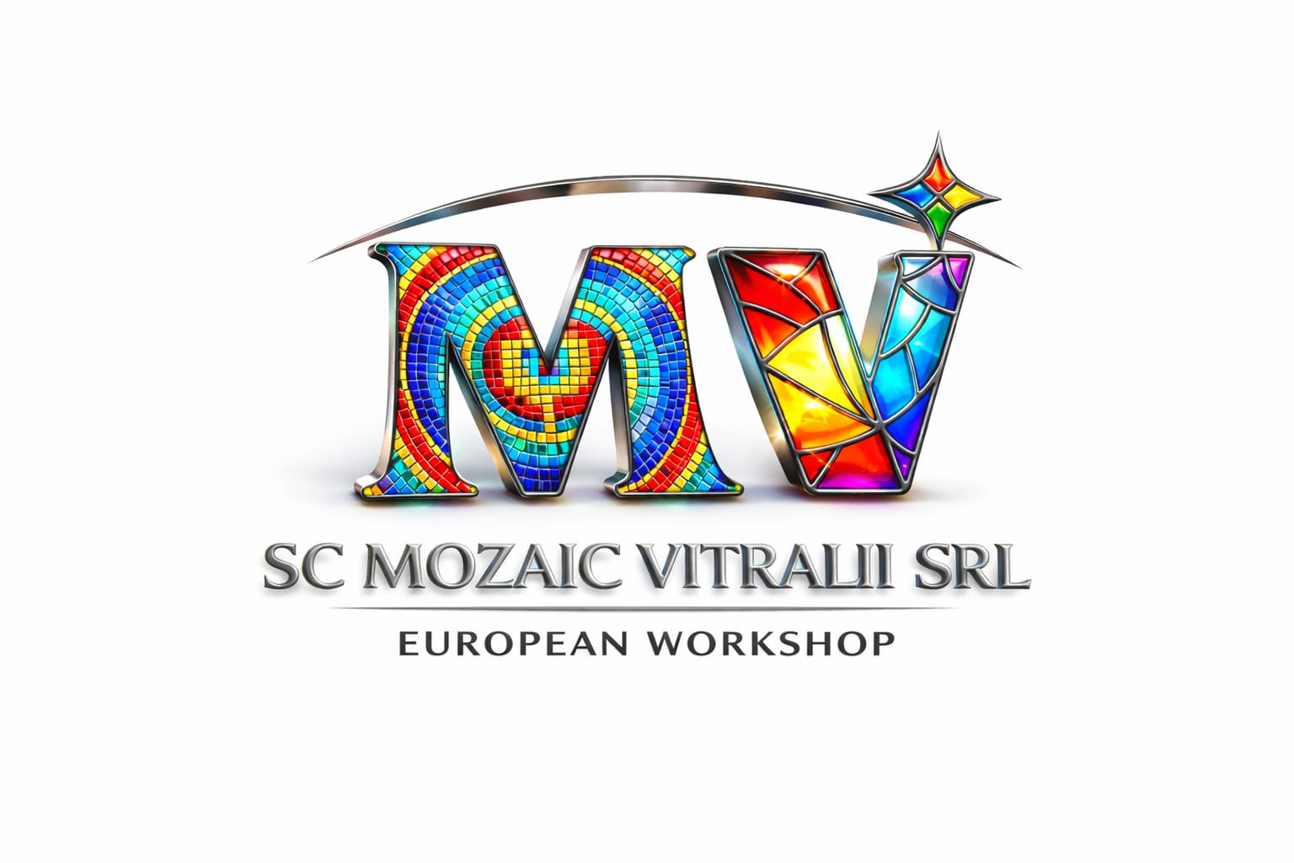

SC Mozaic Vitralii SRL Romania is the successful story of the team of artists who, through innovation and professionalism, have reinvented the creation process of the old byzantine mosaic and of the stained glass by patenting some new original materials.
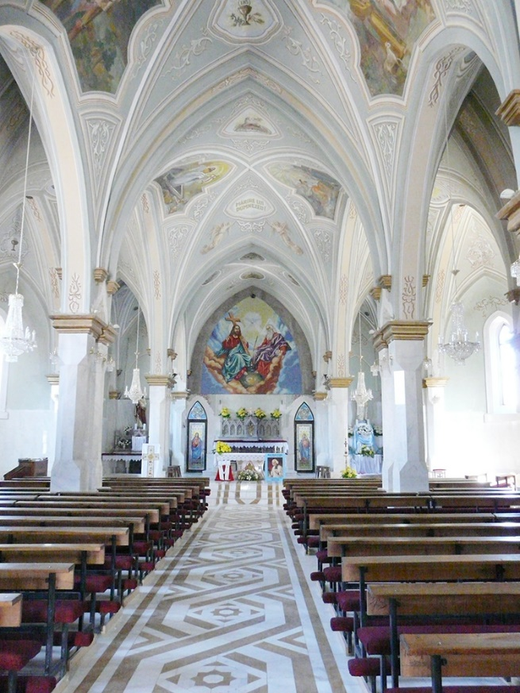
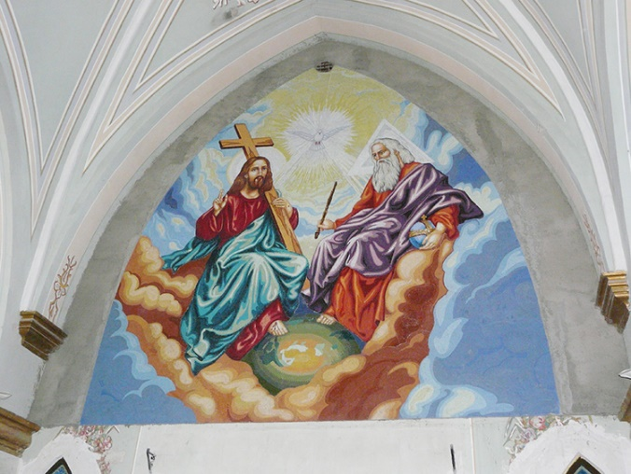

Mosaic example

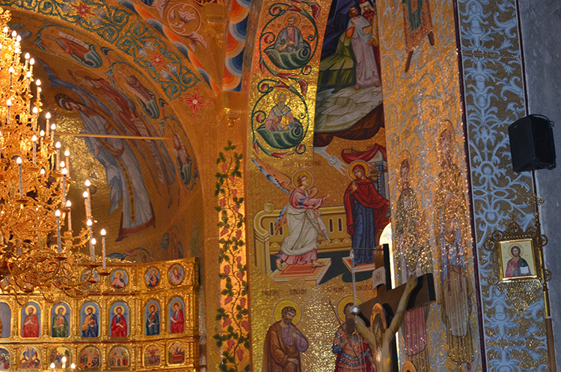
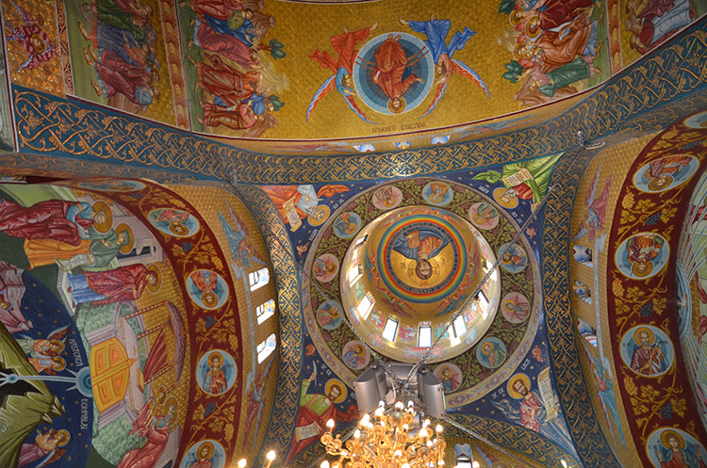

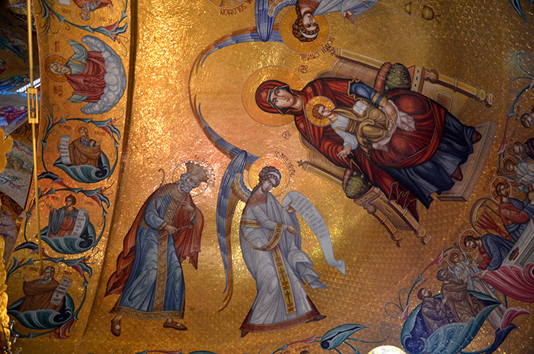

Being in a continuous innovation, the work techniques of SC Mozaic Vitralii SRL combines materials such as fused glass mass by double or triple fusion, with manually painted embossed details, with classic Venetian mosaics (Orsoni) and double glazed mosaic.
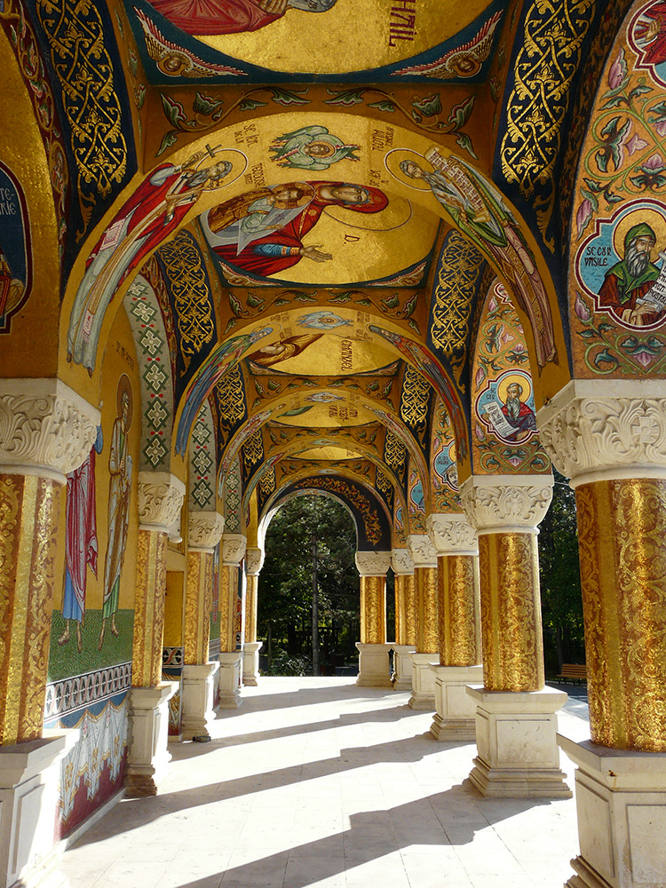
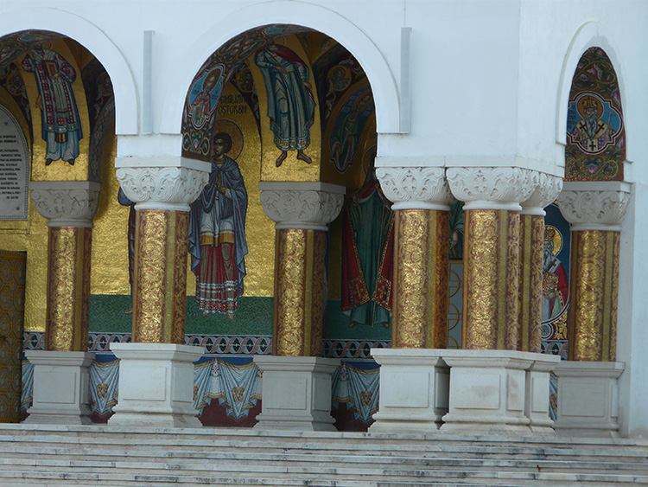
For over 15 years, SC Mozaic Vitralii SRL is the unquestionable equivalent of originality, quality and flawless execution in the exclusivist domain of the stained glass and mosaic.
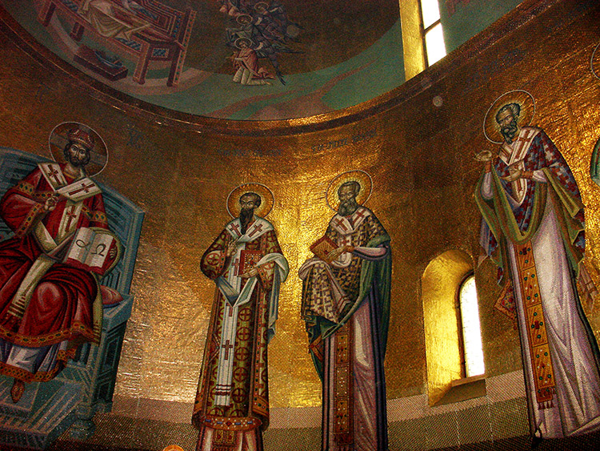
The permanent innovation through patented work techniques and the passion for beauty have brought the national and international appreciation such as four gold medals at the International Salons of Inventions from Brussels, Moscow, Geneva, and Iasi.
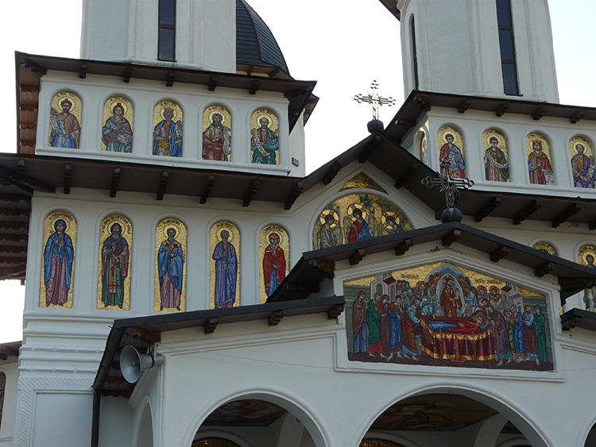
Behind the SC Mozaic Vitralii SRL brand there is a vast experience in the artistic work. This experience is the result of the passion with which each project is delivered and also of the contribution of our artists who can be very proud of their impressive work portfolio.
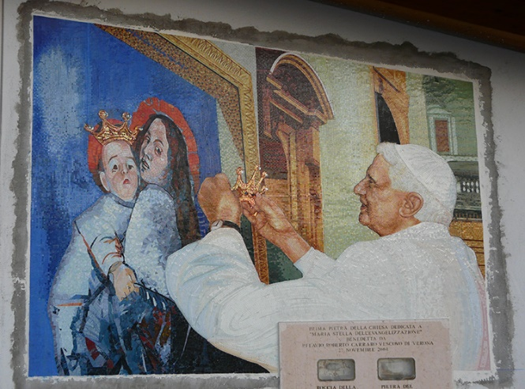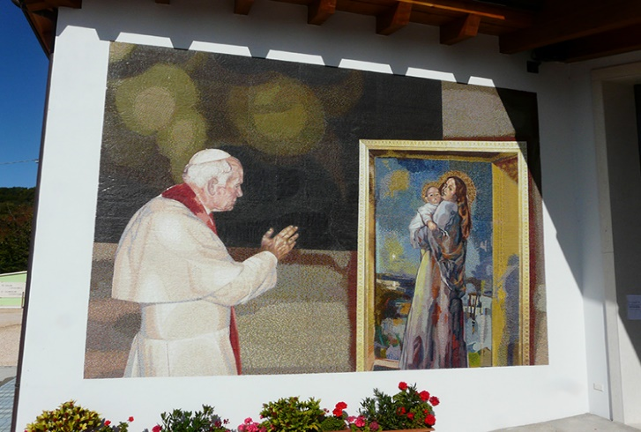
The SC Mozaic Vitralii SRL Collection is renewed every day with unique works of art which arrive in front of you after hours of meticulous painstaking work of a dedicated team including over 200 painters, graphic designers, draughts men, iconographers and mosaic artists whose talent and devotion are reflected in the remarkable creations which decorate and embellish galleries of art, famous churches and cathedrals all over the world, but also private houses and hotels where their artistic value brings a touch of style and elegance. Besides those ten thousands of square meters of mosaic which embellishes a growing number of worshipping places from Romania, SC Mozaic Vitralii SRL has also made extensive works in Greece, Italy, Republic of Moldova, Scotland and Austria.
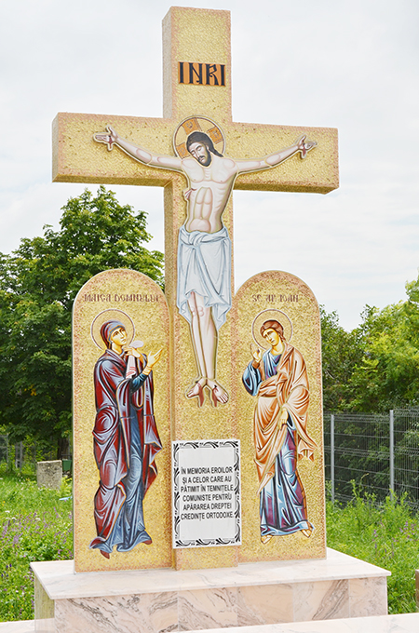
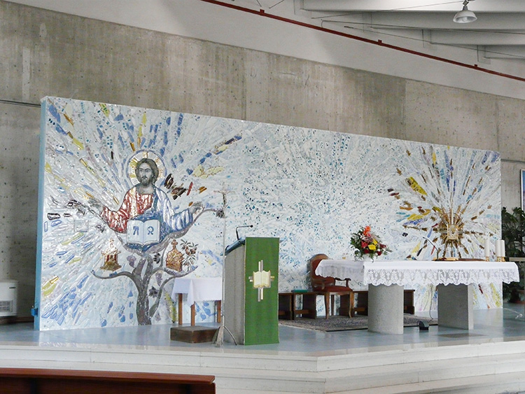
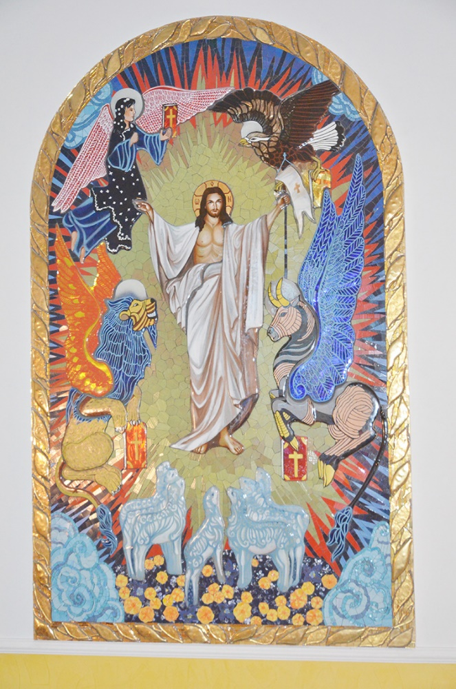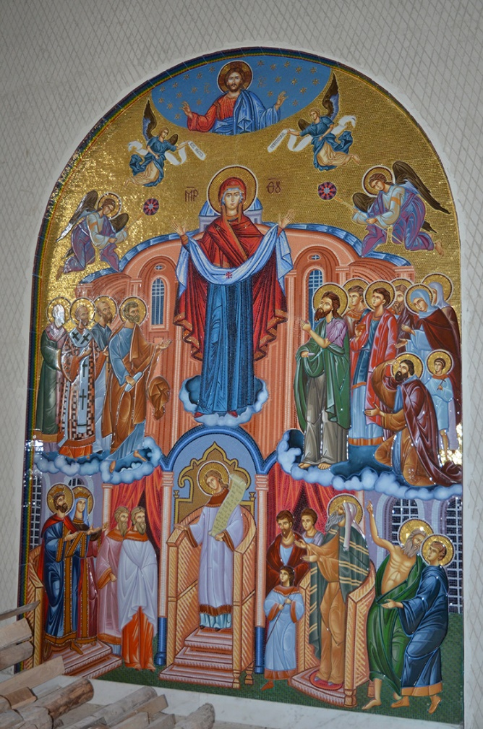
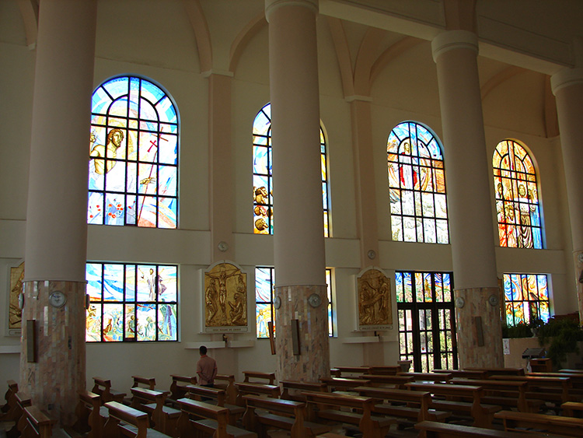
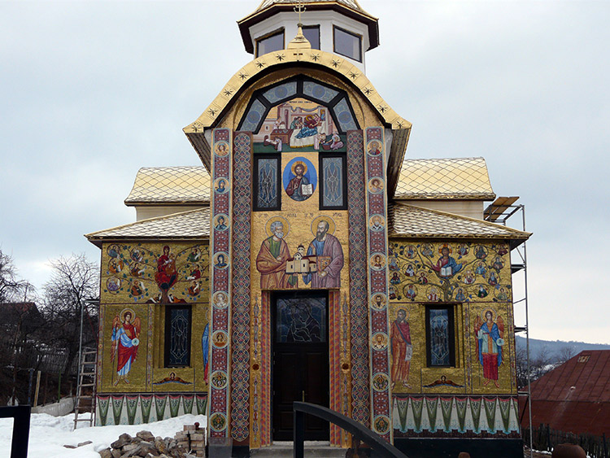
Any idea can be artistically interpreted by our experts and afterwards there is the possibility of custom execution under your order of interior or exterior design project in the SC Mozaic Vitralii SRL style.
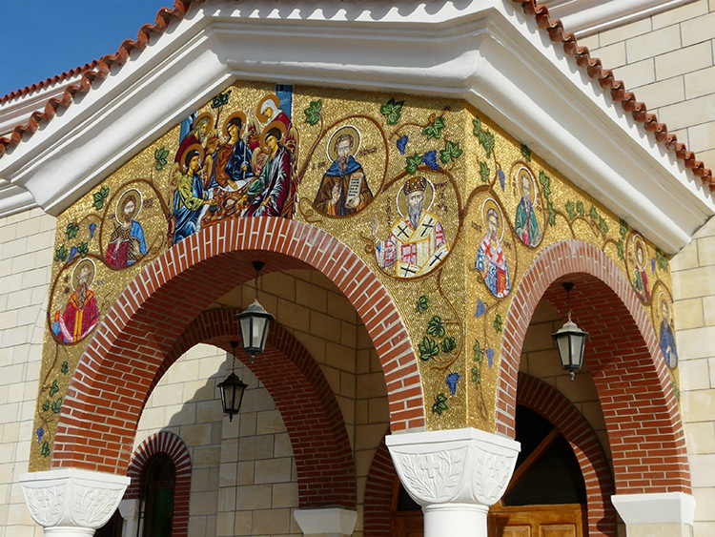
The stained glass is an art style which combines utility with beauty. The painted glass pieces are placed symmetrically and asymmetrically; they are mounted through the lead networks both for windows and for doors.
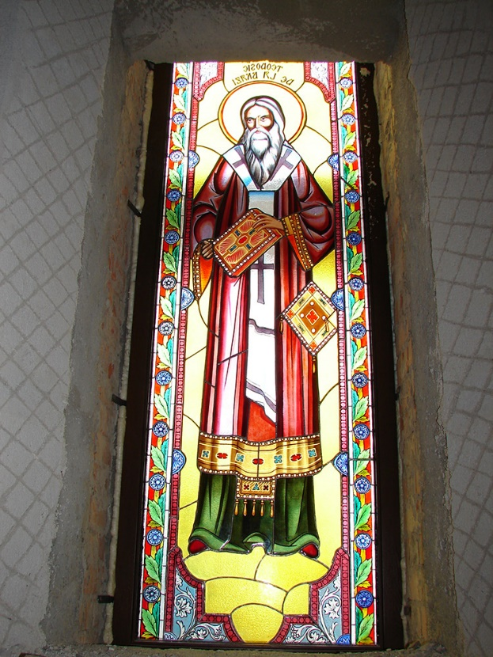
The entire beauty of the painted glass chromatically boosted by light was transferred from the ecclesiastic area to the profane one, thereby increasing the value of the residential interiors.
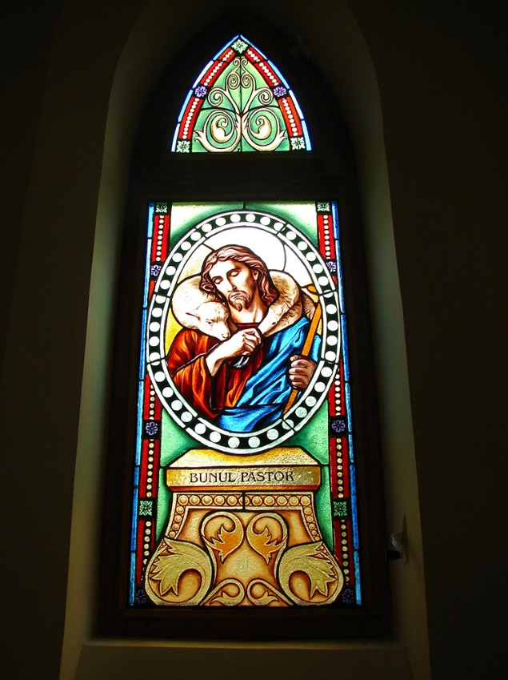

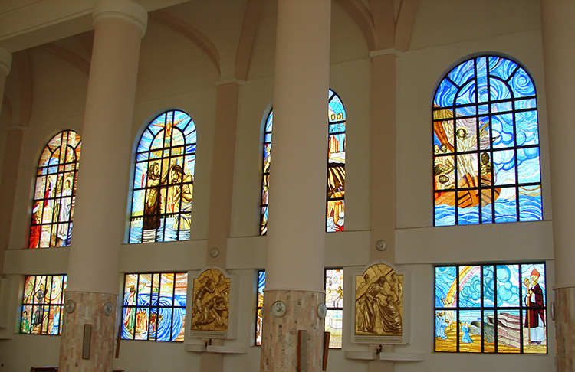
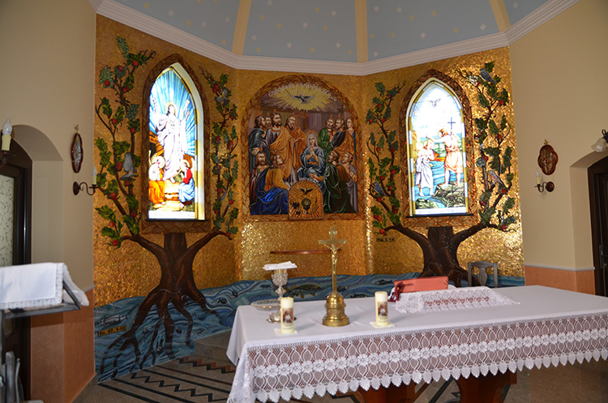

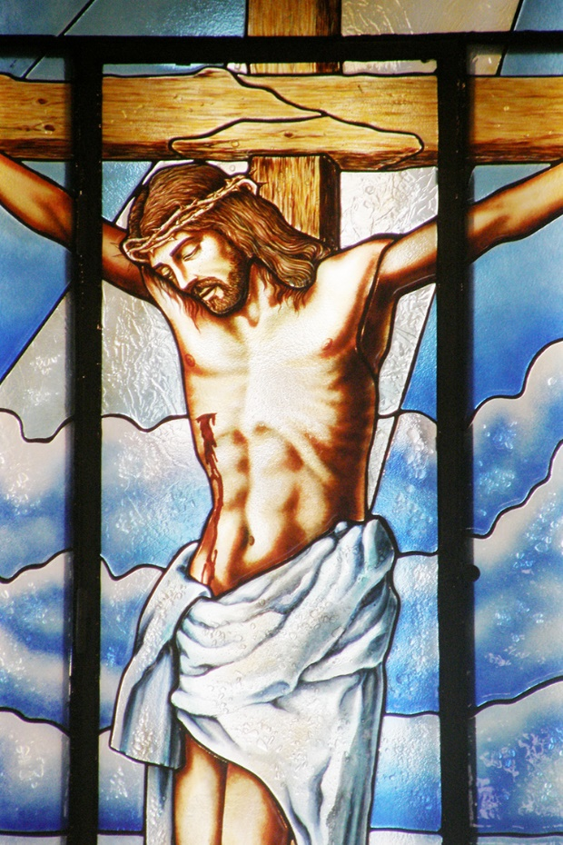

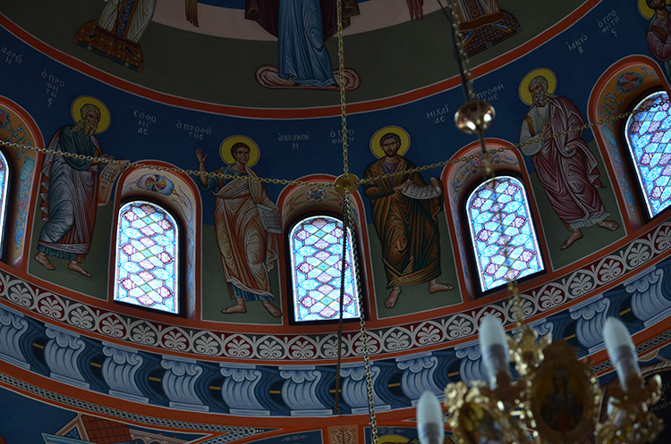

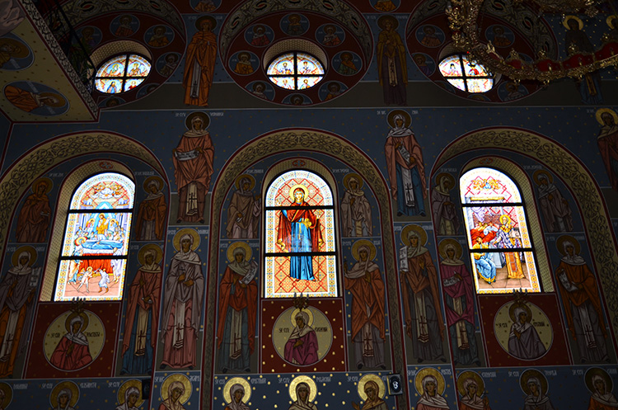
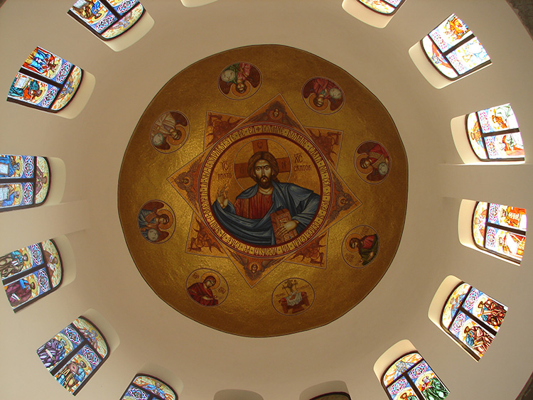
The mosaic, as a decorative piece of work, represents an artistic blend between some marble elements (tessere), granite, glass etc. of different colours held together through a binder such as mortar and mastic.
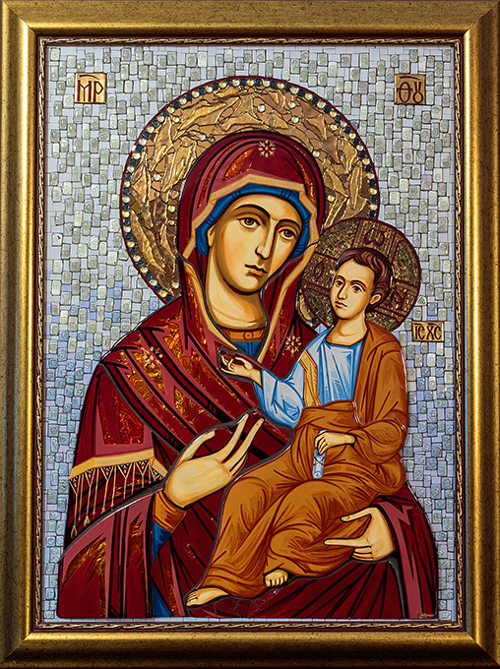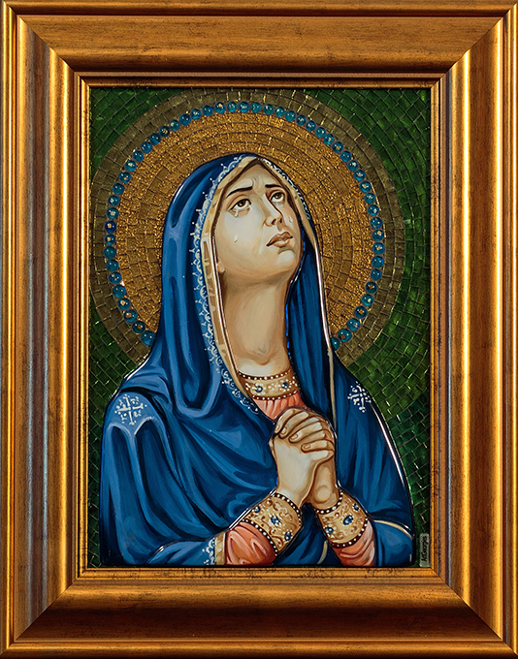


SC Mozaic Vitralii SRL has developed the mosaic techniques using the junctions of the double glazed glass mosaic.